Public Library of Brookline Strategic Plan: FY18-FY22

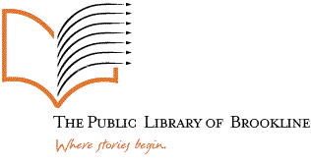
Table of Contents:
- Vision & Mission Statements
- Public Library of Brookline Core Values
- Executive Summary
- Key Themes & Strategic Principles
7. Trustee, Steering, and Staff Committees
8. Timeline
10. About the Public Library of Brookline
14. About Brookline
15. Sample Action Plan Sheet
16. Appendices

Vision Statement
Inspiring Ideas, Enriching Lives, Creating Community

Mission Statement
The Public Library of Brookline promotes discovery, connection, and opportunity for all residents. Through our diverse resources and innovative programs, we aim to enrich the lives of our citizens through free access to information in many different media and formats. We are a cultural destination and a site for learning and recreation, as well as a place where people come together to exchange ideas. We strive to be both a cornerstone of our community and a gateway to explorations of a wider world.

Core Values

The Public Library of Brookline is committed to:

  - Provide free access to information to all members of our community

  - Serve the needs and interests of our residents through our collections, technologies, programming, and services

  - Cultivate learning, literacy, and intellectual and cultural enrichment

  - Provide a forum for lively and open exchange of ideas

  - Collaborate with other Town institutions and organizations, as well as other libraries, to responsibly and efficiently serve our patrons, enrich our collections, and maintain our facilities

Executive Summary
The world is changing at an almost unimaginable pace. As we all try to embrace, understand, and accept new technologies, methods of correspondence, and information delivery models, the time has come for a public library renaissance. Brookline, as a community, has always led its civic cohort through exemplary practices concerning the environment, financial management and practices, education, and library services. In creating the next Strategic Plan, we knew we had to take some giant steps forward in all those areas.
In this dazzling time of change, the Library Trustees chose to look outward towards their community, to gather deep knowledge of what the patrons, the staff, community stakeholders for the library, and (for the first time) non-users of the library, want to see in the future of the Public Library of Brookline.
In our conversations with the community we found that current users value the traditional services: books, magazines, newspapers, and free internet access. In these channels, the library is already succeeding, although there is always room for improvement. Our smaller sample of non-users, on the other hand, think that the library is not keeping up with their dynamic, and in some cases “all digital” lifestyles.
To anticipate and meet patron needs in this new, non-traditional world, we adopted a fresh approach to creating this Strategic Plan. This Strategic Plan is the product of the vibrant collaborative work of many agents. We looked outward to identify community needs and goals using a number of mechanisms including an online survey, in –person, and a “librarian on the street” iPad micro-survey. The Library Board of Trustees contributed their support and many of the final directions for the plan. Ruth Kowal, Library Consultant and former COO of the Boston Public Library guided us through these fresh, and sometimes challenging waters with efficacy and professionalism.
Library Staff members gave generously of their time and expertise to help craft a plan that spoke not just to the 58% of the Brookline population that already hold library cards, but also to the 42% of residents who do not. Library users who attended our Community Conversations and Focus Groups, and users who took our long survey (562 respondents) or who took our “on the street” micro-survey (179 respondents) were integral in the development of the plan. There were two open Community Conversations, and five Focus Groups. The process began in January of 2016, and will be completed in December of 2016.
As we sifted through the data, themes emerged, including a commitment to traditional material formats, an interest in cultural and intellectual pursuits, concern for warm inclusive gathering spaces, strong community partnerships, and a dedication to technology and innovation. We have used these themes as umbrellas under which to place our institutional priorities.
These agents collaborated to bring the goals and needs of the community together with best current practices for public libraries to create the Public Library of Brookline Strategic Plan: FY2018-FY2022.
Sara Slymon
Library Director

Key Themes & Strategic Principles

User Experience
The library strives to meet you where you are. Through welcoming and comfortable public spaces, and an engaging digital environment, we provide access to a broad spectrum of resources. We provide friendly service and personal support for our patrons as they search for information, literature, and entertainment.
- Priority: Create a culture of exemplary customer service, where patrons are given the same quality of helpful attention in person, by phone, or online.
- Priority: Take the library out in to the community, both physically through tools like our Homebound Delivery Service, and the Bookbike, and digitally through virtual services like publiclibraryofbrookline.org and the Minuteman Library Network app.
- Priority: Evaluate the current facilities and improve them to meet the needs and wants of the community through opportunities for hands-on enjoyment, comfortable gathering spaces, small group and study rooms, labs for digital instruction, all in a clean, bright environment with clear wayfinding tools. Creatively re-purpose spaces to meet these needs.

Collections
We are committed to traditional formats and future innovations. We hold intellectual freedom, access to diverse perspectives, and materials which support the interests and needs of the community among our highest values.
- Priority: Provide access to traditional and innovative formats to meet users needs both in and out of the library through book groups, author talks, film festivals, readers advisory, and book displays.
- Priority: Coordinate ease of access to and preservation of the art, artifacts, manuscripts, and other unique historical content in our collections, sometimes known as “hidden collections” Highlight the resources that illuminate the uniqueness of the history of Brookline.
- Priority: Constantly assess current digital content models and, engage in horizon scanning for the next best content provider.
- Priority: Facilitate access to robust world language, career, ESL, citizenship, and literacy collections.

Community Connections
We invite the community to educate us about their needs and interests, and in response we strive to provide services and opportunities to learn, enjoy, and collaborate.
- Priority: Utilize strong, modern, and effective marketing and promotional tools to advertise the wealth of library services to current users and non-users. Fully express what the library has and what the library does in a way that can be heard and understood.
- Priority: Develop outreach to serve the underserved, including, but not limited to patrons limited by mobility, language, or socio-economic barriers.
- Priority: Connect patrons to resources through innovative approaches online and in person.
- Priority: Aggregate community information from town and local agencies, and partner creatively with those agencies to provide the greatest depth of service to our patrons.
- Priority: Promote civic involvement and discussion

Learning and Culture
We nurture the love of learning, literacy, and intellectual curiosity. We cultivate opportunities for individuals to fulfill their personal needs and goals.
- Priority: Provide and promote multicultural and multigenerational programming
- Priority: Encourage the dissemination and enjoyment of arts and culture
- Priority: Develop educational programming and resources to help patrons learn about and navigate important life transitions
- Priority: Emphasize and highlight specialty Librarian skills by advertising their areas of expertise

Innovation & Technology
We are responsive to the ongoing changes in information services. We are committed to assisting people in using and exploring new technologies. We strive to keep pace with advancements in technology based user services.
- Priority: Continually strive to provide access to the most useful and innovative digital tools and equipment.
- Priority: Improve and stabilize WiFi and Broadband Internet access throughout the institution
- Priority: Develop technology training , basic and advanced computer skills, mobile device training, online ESL & citizenship skills, job skills/career development, and micro-credentialing

Trustee Committee
Carol Axelrod, Chair
Vivien Goldman
Regina Healey
Carol Troyen Lohe
Magdalene Moran

Steering Committee
Sara Slymon, Library Director
Anne Reed, Assistant Library Director

Staff Committee
Julie Falsioni
Keiko Nishimoto
Kerry O’Donnelll
Caroline Richardson
Charlotte Ryan
Ting Yin

Strategic Planning Consultant
Ruth Kowal, Library Consultant

Timeline:

1/21/16: Steering & Trustee Committee
1/26/16 Steering Committee
3/22/16: Steering & Trustee Committee
4/7/16: Trustee Committee Approve RFQ for consultant
4/12/16: RFQ sent to Ruth Kowal, Carol Mahoney, and Maureen Sullivan
4/27/16: Trustees award contract to Ruth Kowal
5/4/16 Steering Committee/Consultant: sign contract
6/7/16: Steering Committee, Trustee Committee, and Consultant meet
7/18/16 Steering Committee
7/20/16: Steering Committee
9/6/16: Long Survey Opens
9/15/16: All Staff Focus Group
9/18/16: Brookline Day/Long Survey Closes
9/19/16: Micro-Survey Opens
9/22/16: Trustees, Friends, and Foundation Focus Group
9/23/16: Brookline Village Focus Group
9/25/16: Coolidge Corner Focus Group
9/26/16: Brookline Village Community Conversation
9/28/16: Putterham Focus Group
9/29/16: Coolidge Corner Community Conversation
10/3/16 Micro-Survey Closes
10/4/16: Steering & Staff Committee Meeting
10/4/16: Steering & Trustee Committee Meeting
10/19/16: Update to Board of Trustees
10/25/16: Steering & Staff Committee Meeting
10/25/16: Steering & Trustee Committee Meeting
11/2/16: Steering and Staff Committee Meeting
11/9/16: Presentation of draft to Trustees/Vote

About the Public Library of Brookline:

Library History
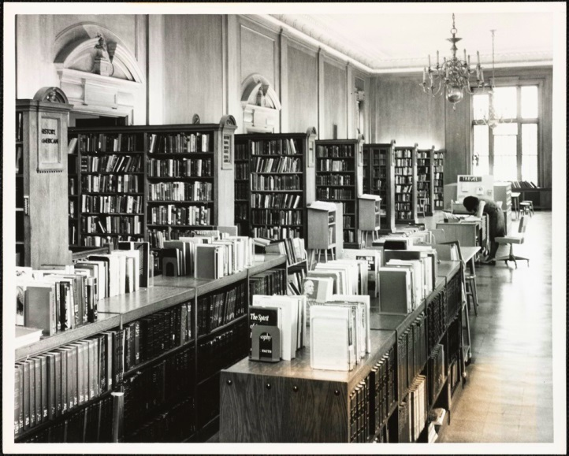The Brookline Public Library plays a distinctive role in the Town and the Commonwealth of Massachusetts, thereby qualifying it for nomination in Heart of the Community: the Libraries We Love, for its architectural, historical and social significance. Located in Brookline Village, the handsome red brick Georgian Revival structure was designed in 1910 by renowned Boston architect R. Clipston Sturgis. The Library is associated with significant people, events and landmarks, notably the establishment of one of the first reading rooms for children in the country.
The present library, dedicated on November 17, 1910, is the second on the site, replacing an 1869 mansard roofed building. Built with brick and Indiana limestone trim, it sits atop a knoll with a circular drive. One of its most impressive features is the oak-paneled reference room with ceiling-high windows and sterling silver chandeliers. The interior of the building was altered and an addition erected in 1970. A further renovation, completed in 2003, creatively added more than 18,000 square feet of public space by eliminating the closed stacks and moving staff offices to newly-created third floor locations, all within the original footprint of the building. The renovation restored the original double entrances, uncovered the grand-columned entrance hall, opened up access to the wings, which had been restricted in 1970, and doubled the floor space of the children’s room. It also allowed the Library to display a large portion of its art collection. Handicapped accessibility was enhanced by adding ramps that continue the design of the original balustraded terrace. This restoration renewed the facility for the 21st century while restoring and preserving almost all of the original architectural elegance. The Brookline Preservation Commission presented the Library with a Preservation Award in 2003.
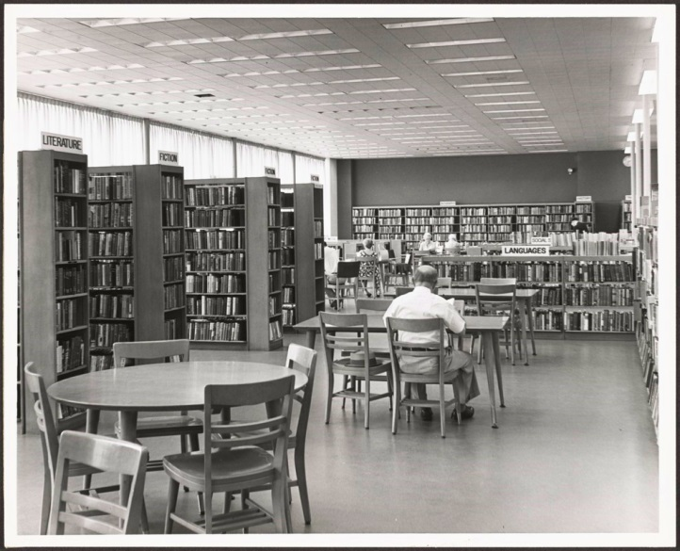The Library as an institution has great historical significance. While not the first public library in Massachusetts, it was the first to be organized under May, 1851 state legislation allowing communities to tax themselves for such purposes. In a vote at the March 30, 1857 Town Meeting, the citizens of Brookline established a free library. Among the prominent patrons and advocates of this institution at the time were William I. Bowditch, an abolitionist and Underground Railroad conductor; Frederick Hedge, a Unitarian minister; Edward Atkinson, businessman, abolitionist and inventor of the Aladdin oven; James S. Whitney, president of Metro Steamship Company; and Amos A. Lawrence, abolitionist and industrialist. In honor of benefactor John L. Gardner, the Art and Music Room was named Gardner Hall.
One of its most momentous legacies is the establishment of a separate reading room exclusively for children in April, 1890. The Brookline model was influential in sparking the expansion of library services to children across the country. In 1899, a reference room for children was established with its own librarian. Until 1969, the public school libraries were under the auspices of the Public Library. With the 2003 renovation, a child-sized door was added at the entrance to the new children’s room, the space doubled in size, and a large multi-purpose room was created for story hours and other activities.
By 1898, the Brookline Library was sufficiently impressive to elicit this evaluation by Melville Dewey: “There are few institutions of the country concerning which I should be willing to speak more frankly to one of their officials. The Brookline Public Library is commonly looked on by those familiar with library work of its type through the country, as among the foremost in efficiency and influence. It has won a place where it is often quoted and referred to as the type of the best American public library.” The Library today continues this efficiency and influence. Since re-opening in January 2003, usage has increased over 20% helping to make the Public Library of Brookline the third most heavily-used public library in Massachusetts.
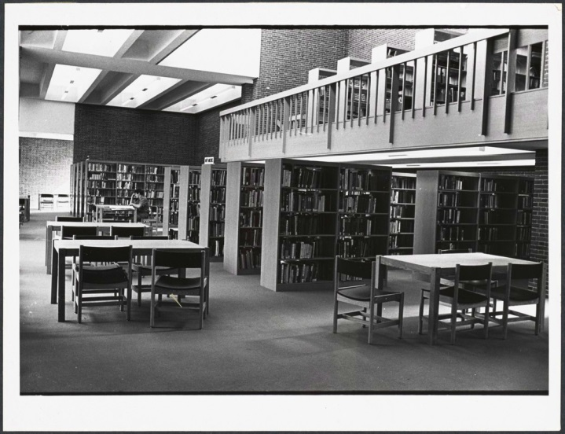Since its inception, the Brookline Public Library has been a center of the social and cultural life of the town. In addition to the services provided in the Library, it also established school and social welfare libraries, outreach programs in the public school, deposit branches, book delivery to servicemen during the wars, and services to the homebound. The Public Library also has two branches, Coolidge Corner and Putterham, serving the community with additional programs. The Library has been the home to many Brookline organizations: the Brookline Library Music Association; the Brookline Bird Club; the Brookline Art Association; the Brookline Education Society and the Brookline Civic Association. The Brookline Historical Collection, with photographs and archival material, was established in 1894. Friends of the Brookline Public Library, established in 1981, run book sales and sponsor programs for the community and staff enrichment. Incorporated in 1999, the Brookline Library Foundation carries on fundraising to support Brookline libraries.
The staff and Trustees of the Brookline Public Library have continued this tradition of service to and engagement in the community. The staff prepares ongoing exhibits, book displays and leads book discussion groups for children , young adults and adults. Additional programs include a Friday morning film program for children, story hours for toddlers and three- to four-year-olds, and a film program for seniors. The Brookline Library Music Association sponsors a concert series. An all-town reading program, Brookline Reads, has been established to inspire Brookline residents to read a common book and engage in community-wide discussions about the work. In celebration of the Town’s tercentenary, the Library sponsored a town- wide photography contest, Picturing Brookline, that was open to all residents, from 4th grade students to professional photographers. All the submissions were placed in albums that are kept in the Library’s archive, and made available for future generations. The Library houses the recently-established Brookline 300 display case that will be a visible, ever-changing window on Brookline’s past.
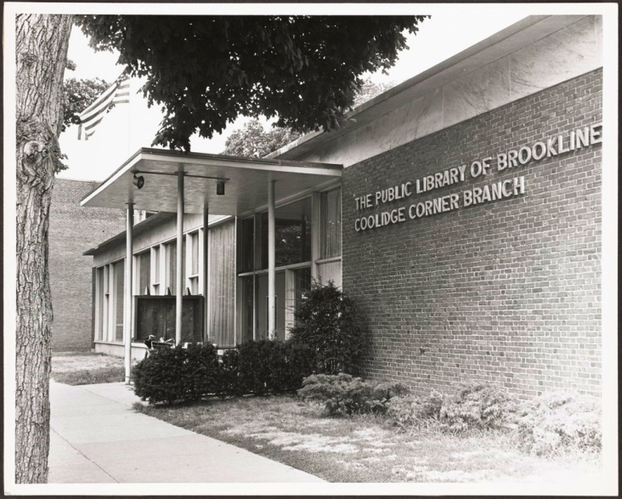Over its 148 years, the Brookline Public Library has encouraged, molded, inspired, and nurtured many important icons of local, regional, and national culture. These people have not only played a role in the community, but have also contributed to our nation’s history. They include landscape architects Charles Sprague Sargent and Frederick Law Olmsted, Senior and Junior; art world patron Isabella Stewart Gardner and sculptor Theo Ruggles Kitson; abolitionists William I. Bowditch and Edward Atkinson; film-makers William A. Wellman and the Maysles brothers; musicians Arthur Fiedler and Roland Hayes; social activists Minna Hall and Harriet Lawrence Hemenway (founders of the Massachusetts Audubon Society); politicians John F., Robert F., and Edward M. Kennedy; scientist Percival Lowell; Nobel winners George Minot, William Murphy, and Norman F. Ramsey; personalities Mike Wallace and Conan O’Brian; writers Olive Prouty, Amy Lowell, Jane Holtz Kay, Ellen Goodman, and Arthur Golden; actress Jane Alexander, vaudevillian B.F. Keith; and sports executives Theo Epstein and Bob Kraft.
The Brookline Public Library, a member of the Minuteman Library Network, provides access to the collections of 41 area libraries. It houses historical Brookline collections including photographs, manuscripts, books, and artifacts, and offers programs for residents of all ages. As a vital community center, the Library has continued to provide excellent service while maintaining the delicate balance of preserving its rich history and embracing new technologies of the future. The Brookline Public Library deserves to be recognized as an important and influential contributor to American cultural, political and social history.
Prepared by Brookline Library History Committee
January, 2006
To commemorate the 150th Anniversary of the Public Library of Brookline, reference staff members Cynthia Battis, Anne Reed, and Anne Clark wrote a new history of the Library entitled Public Library of Brookline: A History: Celebrating 150 Years of Library Service, 1857-2007.

About Brookline:

The Town of Brookline, Massachusetts is a suburban community completely surrounded by the City of Boston. Founded in the 17th century, Brookline has a rich history with cultural, military, and intellectual depth, and was originally known as Muddy River, a fact still reflected in the Town Seal. Through the centuries, Brookline continued to grow and thrive.

“As of the census of 2010, there were 58,732 people, 24,891 households, and 12,233 families residing in the town. The population density was 8,701.0 people per square mile (3,247.3/km²). There were 26,448 housing units at an average density of 3,889.6 per square mile (1,501.9/km²). The racial makeup of the town was 73.3% White, 3.4% Black or African American, 0.12% Native American, 15.6% Asian (6.7% Chinese, 2.6% Indian, 2.3% Korean, 1.8% Japanese), 0.03% Pacific Islander, 1.01% from other races, and 3.0% from two or more races. Hispanic or Latino of any race were 5.0% of the population (0.9% Mexican, 0.8% Puerto Rican). (Source: 2010 Census Quickfacts)
There were 25,594 households out of which 21.9% had children under the age of 18, living with them, 38.4% were married couples living together, 7.1% had a female householder with no husband present, and 52.2% were non-families. 36.7% of all households were made up of individuals and 10.1% had someone living alone who was 65 years of age or older. The average household size was 2.18 and the average family size was 2.86.
In the town the population was spread out with 16.6% under the age of 18, 11.7%, from 18 to 24, 37.3% from 25 to 44, 21.9% from 45 to 64, and 12.4% who were 65 years of age or older. The median age was 34 years. For every 100 females there were 82.6 males. For every 100 females age 18 and over, there were 79.1 males.
The median income for a household in the town was $66,711, and the median income for a family was $92,993. Males had a median income of $56,861 versus $43,436 for females. The per capita income for the town was $44,327. About 4.5% of families and 9.3% of the population were below the poverty line, including 5.3% of those under the age of 18 and 7.5% of those ages 65 and older.
Serving as a residential zone for nearby academic and medical institutes such as Harvard Medical School and Boston University, the town of Brookline was reported as the city with the most doctoral degree holders (14.0% of total population) in the United States.” –Wikipedia

Brookline prides itself on its status as a Town and the virility of its citizen led representative government.

